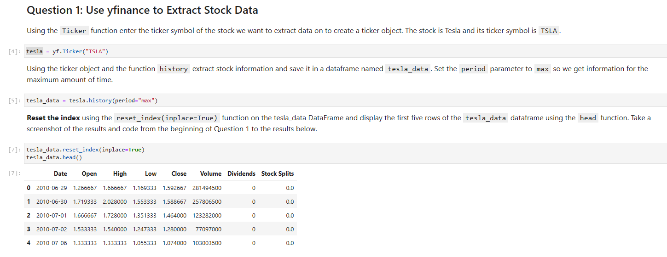

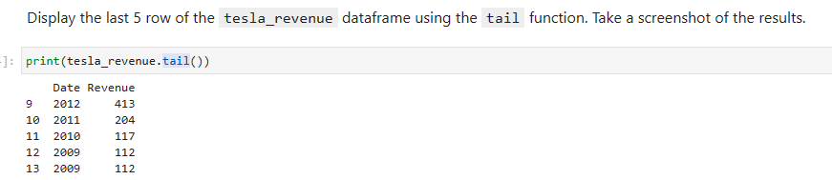

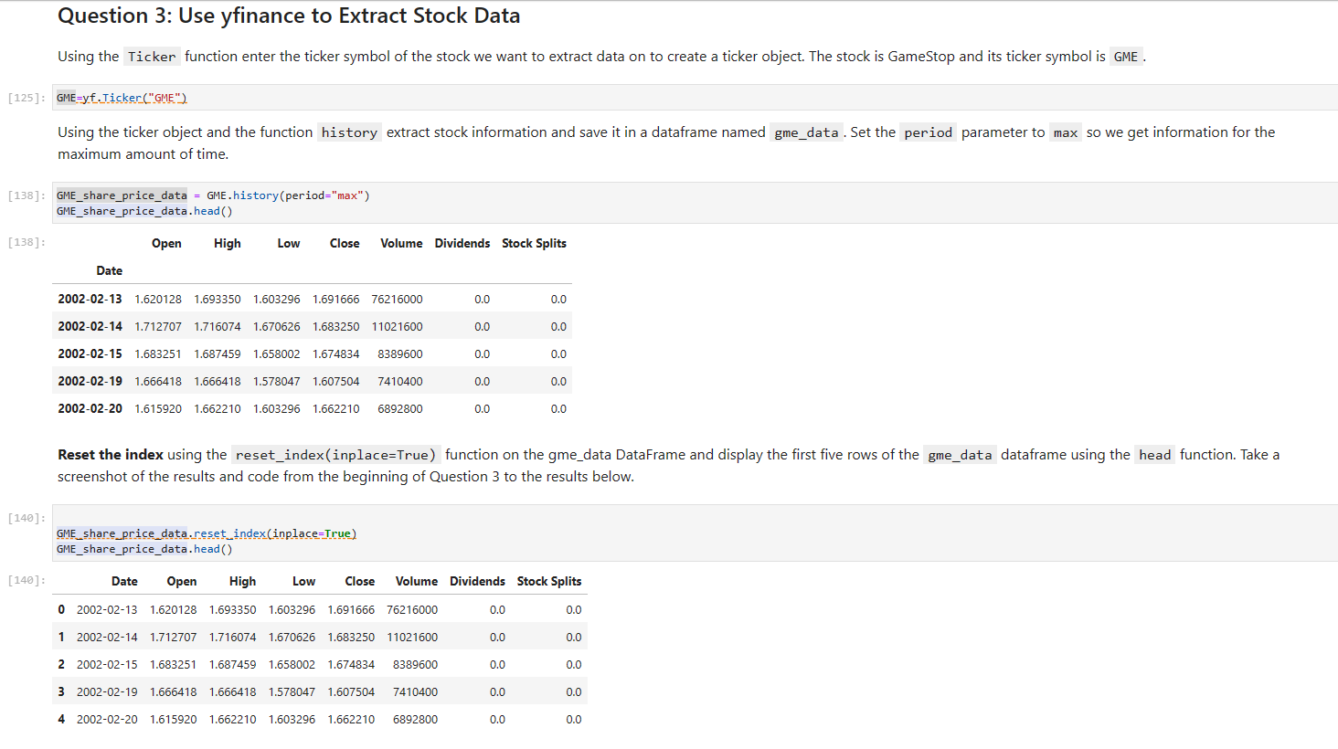

https://jupyterlab-1-labs-prod-jupyterlab-us-east-0.labs.cognitiveclass.ai/hub/user-redirect/lab/tree/labs/PY0220EN/Final%20Assignment.ipynb

Copied path:

labs/PY0220EN/Final Assignment.ipynb

Downloadable link:

<https://jupyterlab-1-labs-prod-jupyterlab-us-east-0.labs.cognitiveclass.ai/user/synhorst93/files/labs/PY0220EN/Final%20Assignment.ipynb?_xsrf=2%7Cb80d55ce%7C38c085a8586dc6a8b52a6ea27976a9be%7C1688754245>

tesla_revenue['Revenue'].str.replace(',|\$',"")

#tesla_revenue["Revenue"] = tesla_revenue["Revenue"].str.replace({'\$': '', ',': ''}, regex=True)

tesla_data["Revenue"] = tesla_data['Revenue'].str.replace('[$,]', "", regex=True)

tesla_revenue["Revenue"]= tesla_revenue['Revenue'].str.replace("$","").str.replace(",","")

not sure why this was in the GME section under reset the index

!wget https://cf-courses-data.s3.us.cloud-object-storage.appdomain.cloud/IBMDeveloperSkillsNetwork-PY0220EN-SkillsNetwork/data/tsla.json

import json

with open('tsla.json') as json_file:

tsla_info = json.load(json_file)

# Print the type of data variable

#print("Type:", type(apple_info))

tsla_info

I edited the TSLA data

!wget https://cf-courses-data.s3.us.cloud-object-storage.appdomain.cloud/IBMDeveloperSkillsNetwork-PY0220EN-SkillsNetwork/data/gme.json

import json

with open('gme.json') as json_file:

gme_info = json.load(json_file)

# Print the type of data variable

#print("Type:", type(apple_info))

gme_info

soup.find_all("tbody")

tesla_revenue=pd.DataFrame(columns=['Date','Revenue'])

for row in beautiful_soup.find('tbody').find_all('tr'):

col = row.find_all("td")

date = col[0].text

revenue = col[1].text

tesla_revenue = tesla_data.append({"Date":date, "Revenue":revenue}, ignore_index=True)

tesla_revenue.head()

tables=beautiful_soup.find_all("table")

for index,table in enumerate(tables):

if("Tesla Quarterly Revenue" in str(table)):

table_index=index

tesla_revenue=pd.DataFrame(columns=["Date","Revenue"])

for row in tables[table_index].tbody.find_all('tr'):

col=row.find_all("td")

if(col!=[]):

date=col[0].text

revenue=col[1].text.strip().replace("$","").replace(",","")

tesla_revenue=tesla_revenue.append({"Date":date,"Revenue":revenue},ignore_index=True)

tesla_revenue.head()

read_html_pandas_data = pd.read_html(url)

read_html_pandas_data = pd.read_html(str(soup))

tesla_data = read_html_pandas_data[0]

tesla_data.head()

soup = BeautifulSoup(html_data, 'html.parser')

tesla_quarterly_revenue_table = soup.find_all("tbody")[1]

tesla_quarterly_revenue_table=pd.DataFrame(columns=['Date','Revenue'])

for row in tesla_quarterly_revenue_table.find_all('tr'):

col = row.find_all("td")

date = col[0].text

revenue = col[1].text

tesla_quarterly_revenue_table = tesla_data.append({"Date":date, "Revenue":revenue}, ignore_index=True)

tesla_quarterly_revenue_table.head()

#print(tesla_revenue.tail())

*************************************************************************************

tesla_revenue["Revenue"] = tesla_revenue['Revenue'].str.replace(',|\$','', **regex=True**) will Solve the Problem